**Effective Heart Disease Prediction Using**

**IBM Auto AI Service**

 Dr. Baljeet Kaur

1. **INTRODUCTION**
2. **Overview**

Cardiovascular diseases (CVDs) are the number 1 cause of death globally, taking an estimated 17.9 million lives each year, which accounts for 31% of all deaths worldwide. Heart failure is a common event caused by CVDs and this dataset contains 9 features that can be used to predict deathrate by heart failure.

1. **Purpose**

In this project, you need to build a model using Auto AI and build a web application where we can showcase the prediction of heart failure.

1. **LITERATURE SURVEY**
2. **Existing problem**

Existing approaches use Machine Learning. Data Scientist has to apply multiple algorithms and compare the accuracy of different algorithms to identify the best solution.

The given problem of heart disease prediction contains the data of various patients and contains information about the average number of heart beats per minute coma number of pulse petitions per day, cholesterol level of the patient, BMI, Age, Sex, Family History, either the person is smoker for last 5 years, how much time a person gives for exercise for week in minutes.  Based on this given data as an input, the data has information about either the person had a heart failure or not.  This information can be used to predict that the person will have a heart failure or not based on the other input parameters provided.  Here the target variable is categorical in nature.  It is a problem of classification, which can be solved by using Logistic regression or decision trees or by using random forest algorithm.  Multiple solutions are possible for this given problem.  Data scientist has to apply all these algorithms on the given data and then the compare the accuracy of the algorithms to finalize the final machine learning algorithm for the given problem.

1. **Proposed solution**

The auto AI solution provided by IBM cloud environment, where we can create a service in Watson studio and provide the given data as an input, the auto AI service in Watson Studio will suggest your multiple machine learning algorithms which are suitable for the given data.  The data scientist no need to worry about execution of multiple algorithms at their end, they can concentrate on the solution without spending more time on preprocessing of the data.  The auto AI solution, AI experiment helps to create a model, Deploy the ML model as a webserver, Integrating Model and Node-RED Service and Build an Application using Node-RED which takes inputs from the user and showcases the prediction on UI.

1. **THEORITICAL ANALYSIS**
   1. Block diagram

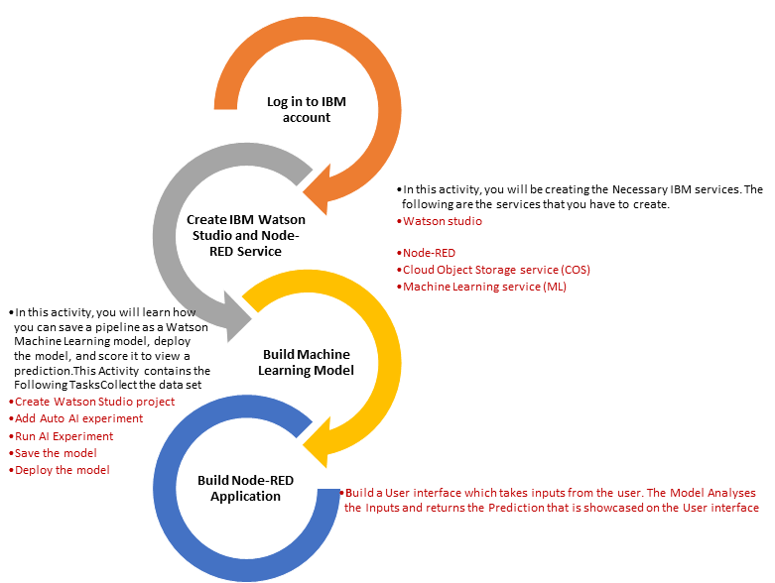

* 1. Hardware / Software designing

IBM Cloud Account with Cloud Object Storage service (COS)

Watson studio

Node-RED

Machine Learning service (ML)

1. **EXPERIMENTAL INVESTIGATIONS**

Creation of Auto AI Experiment for Heart Decease:

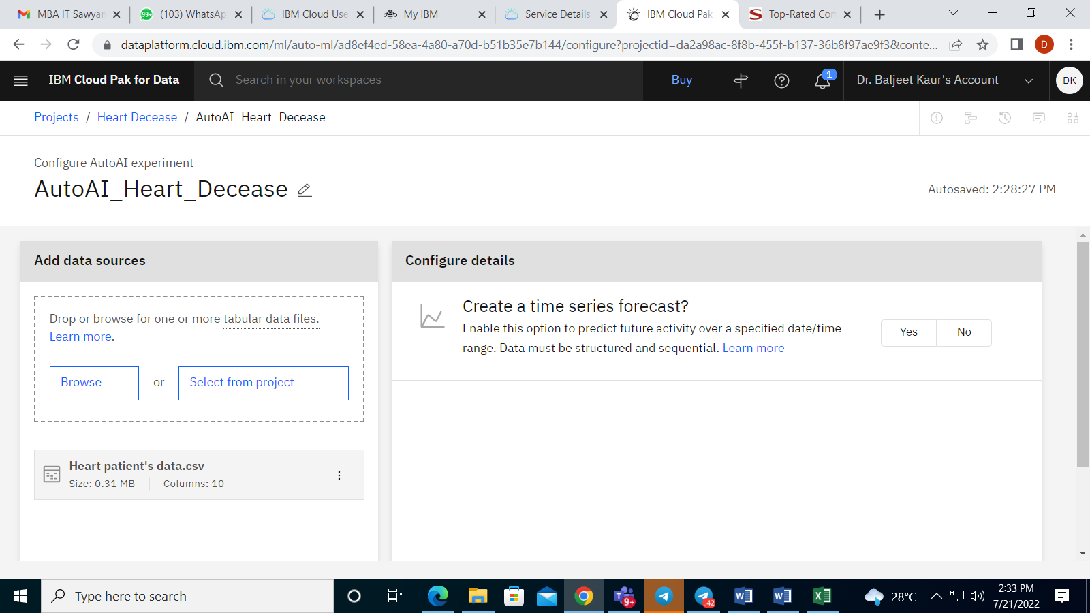

 Importing Data Set and Setting up Experiment

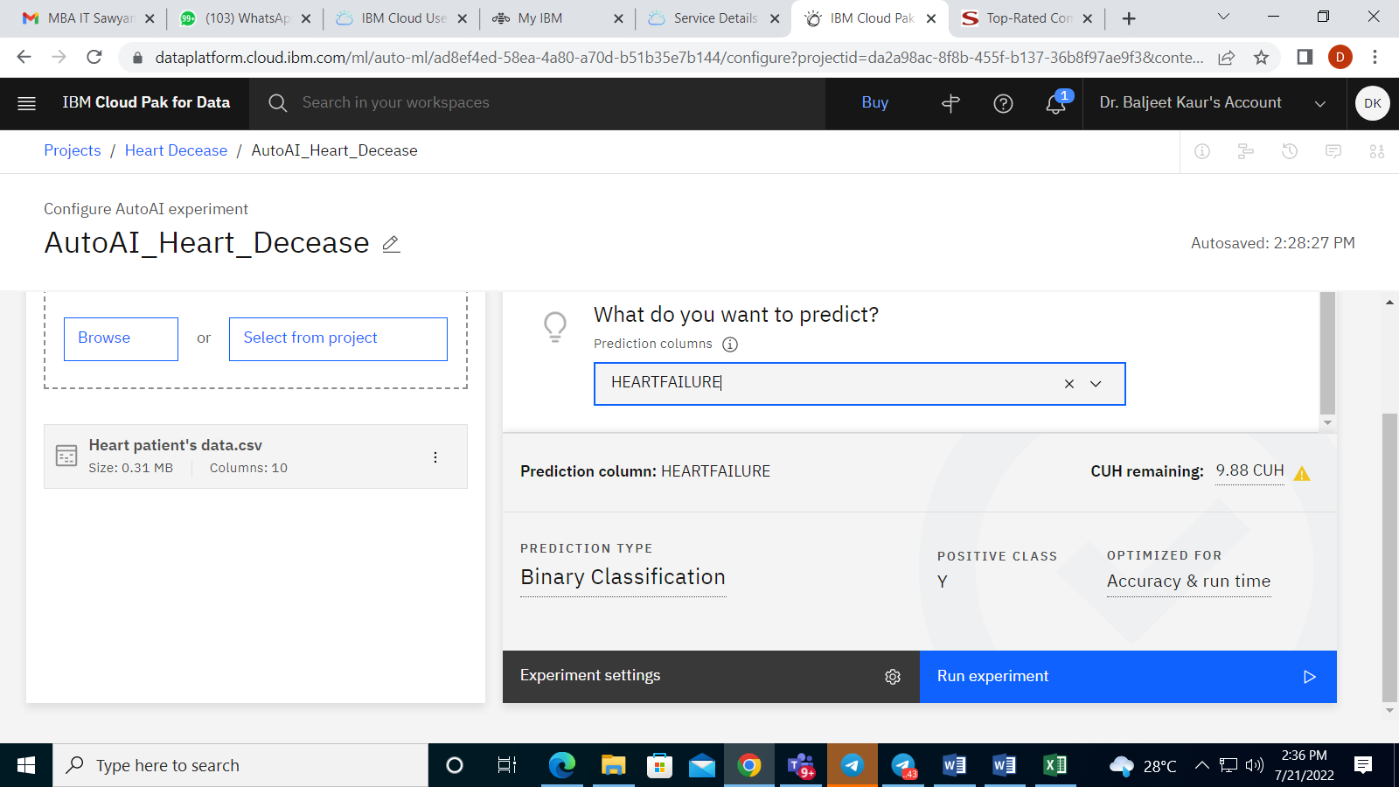

Execution of Experiment:

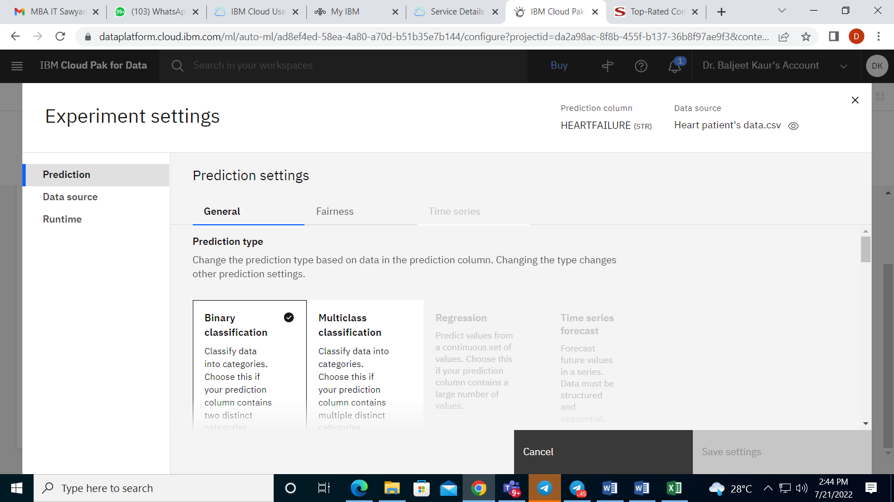

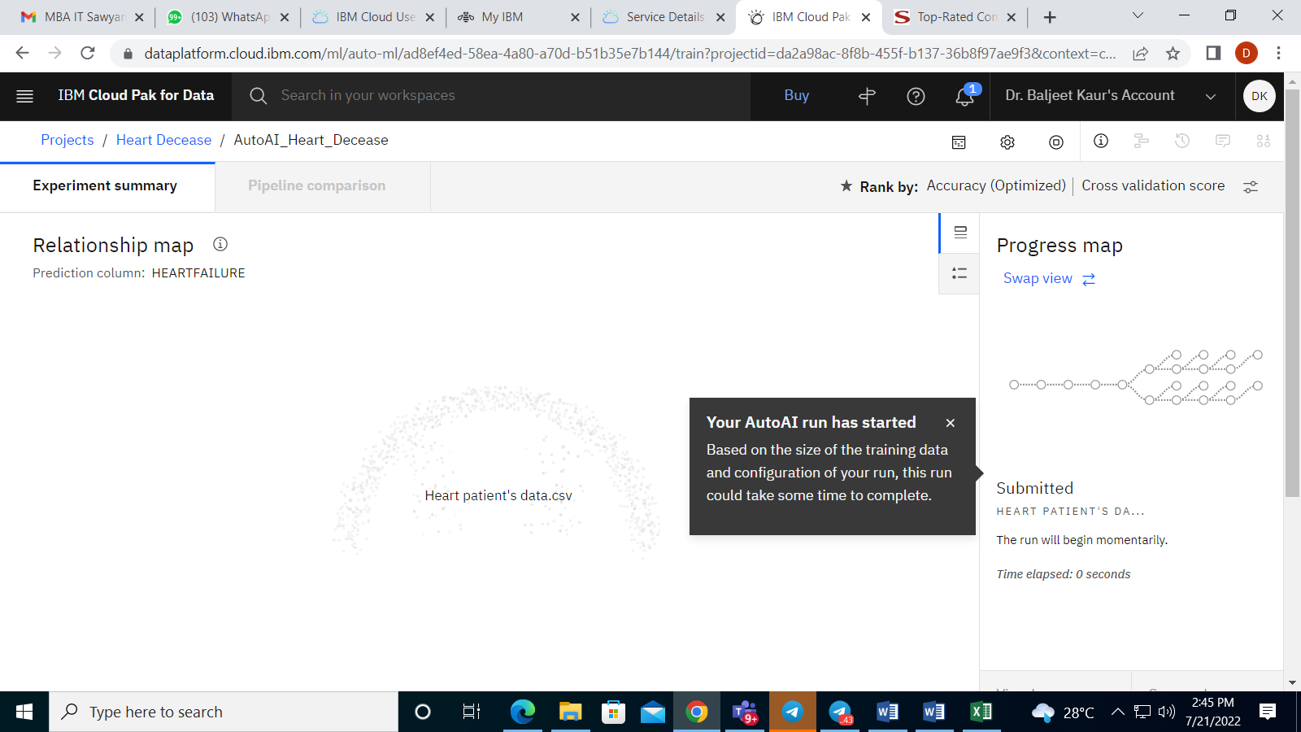

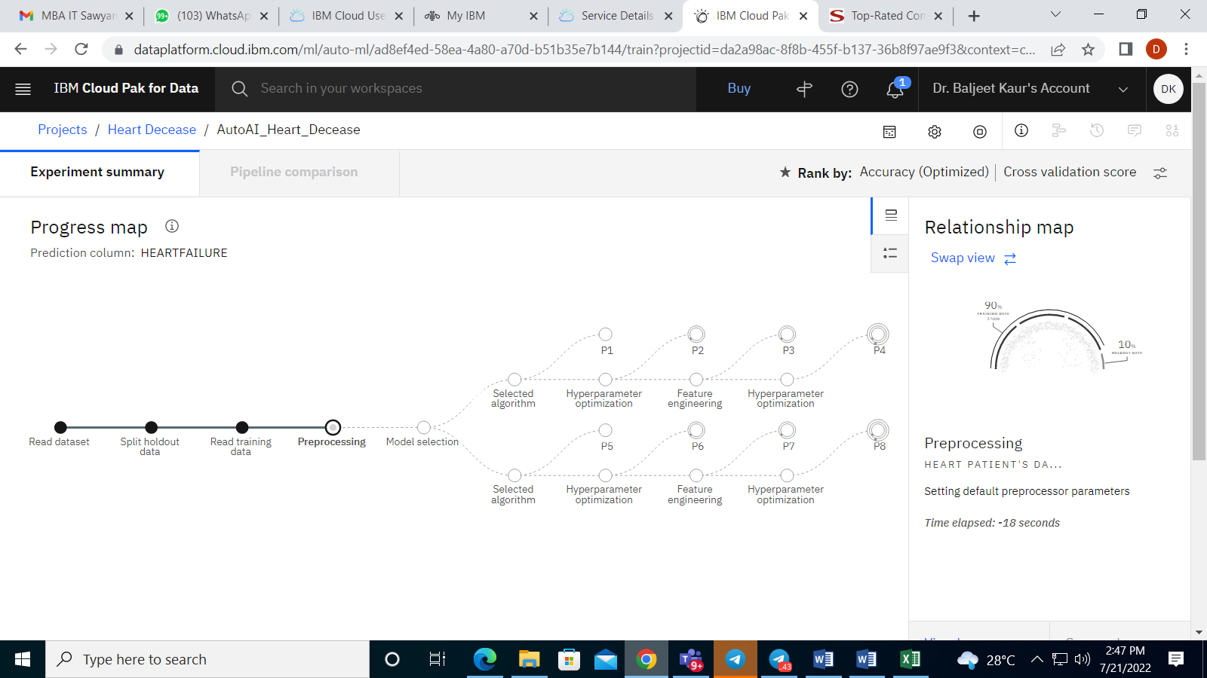

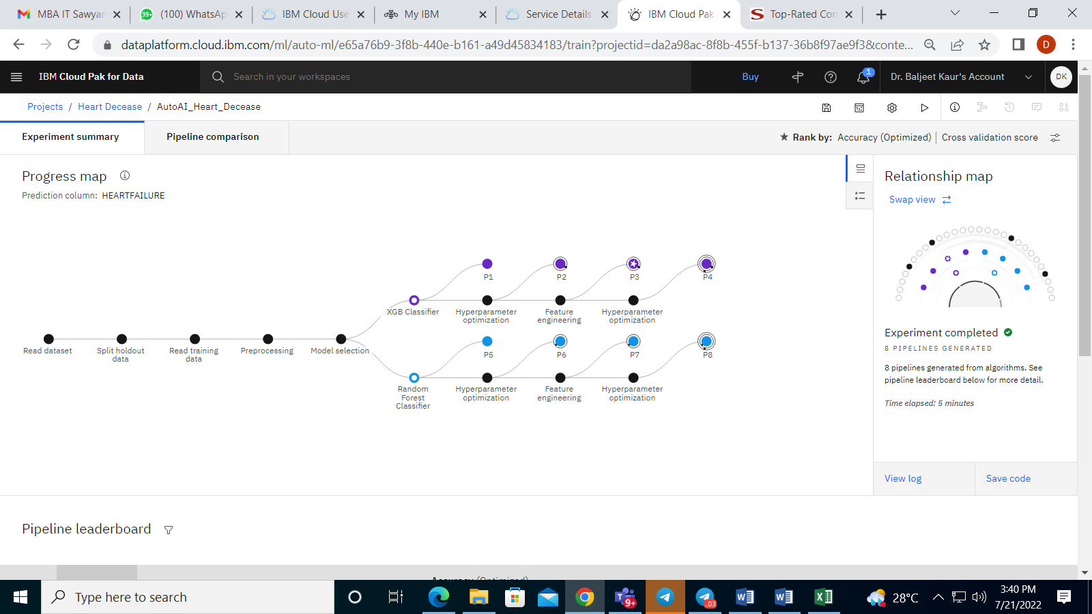

Model pipeline:

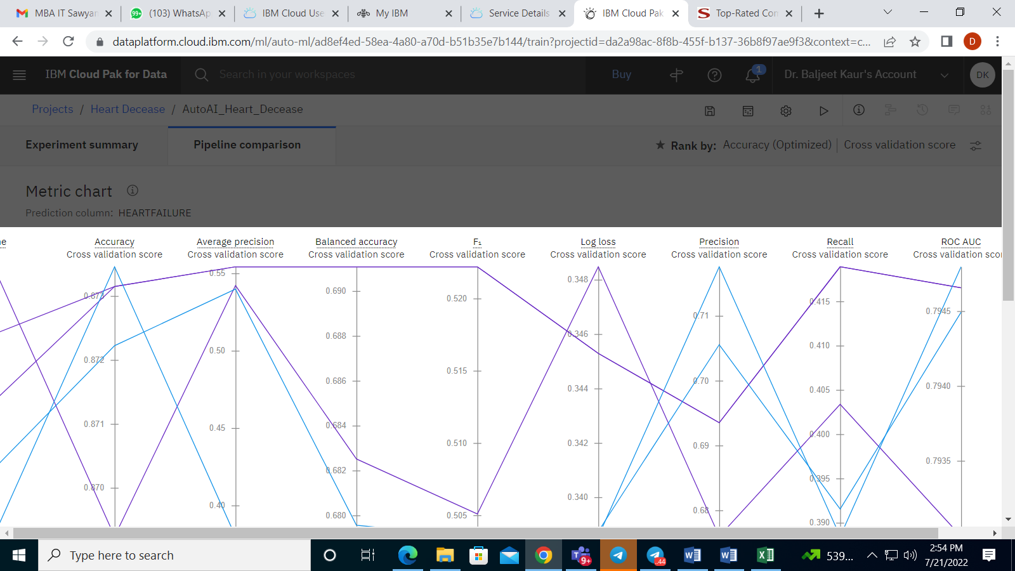

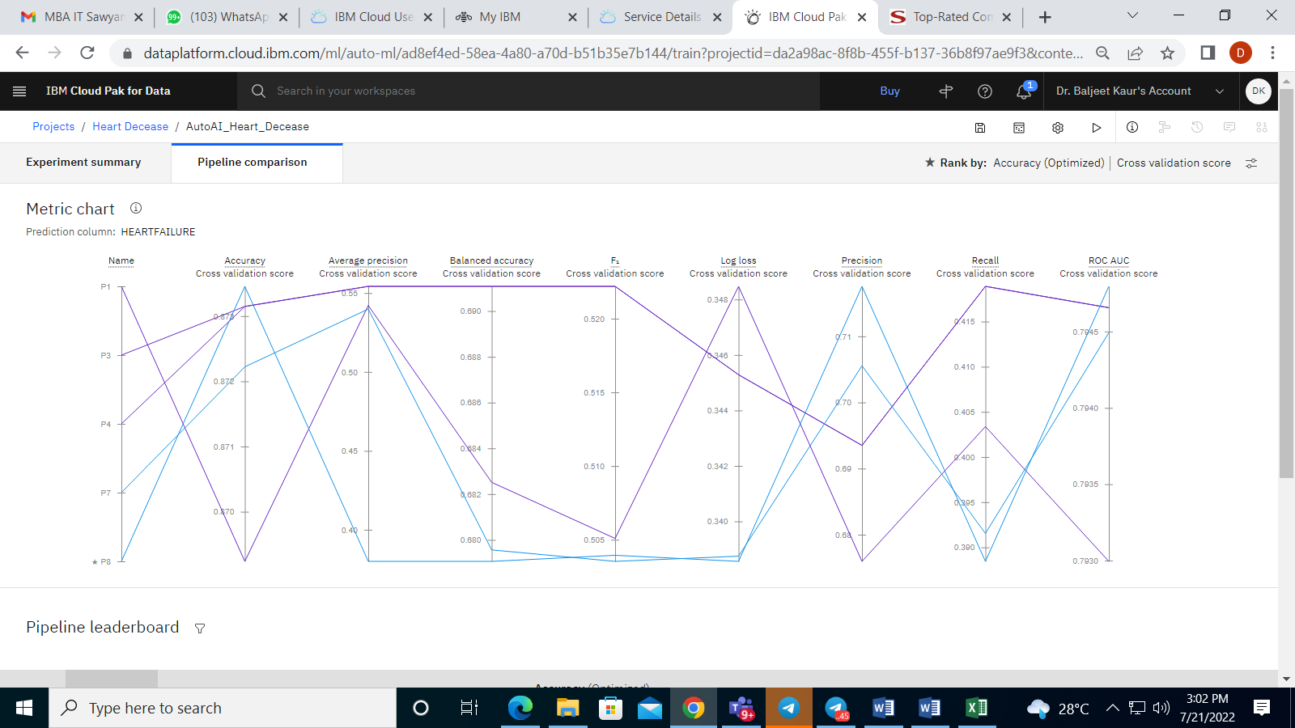

Comparison of Results:

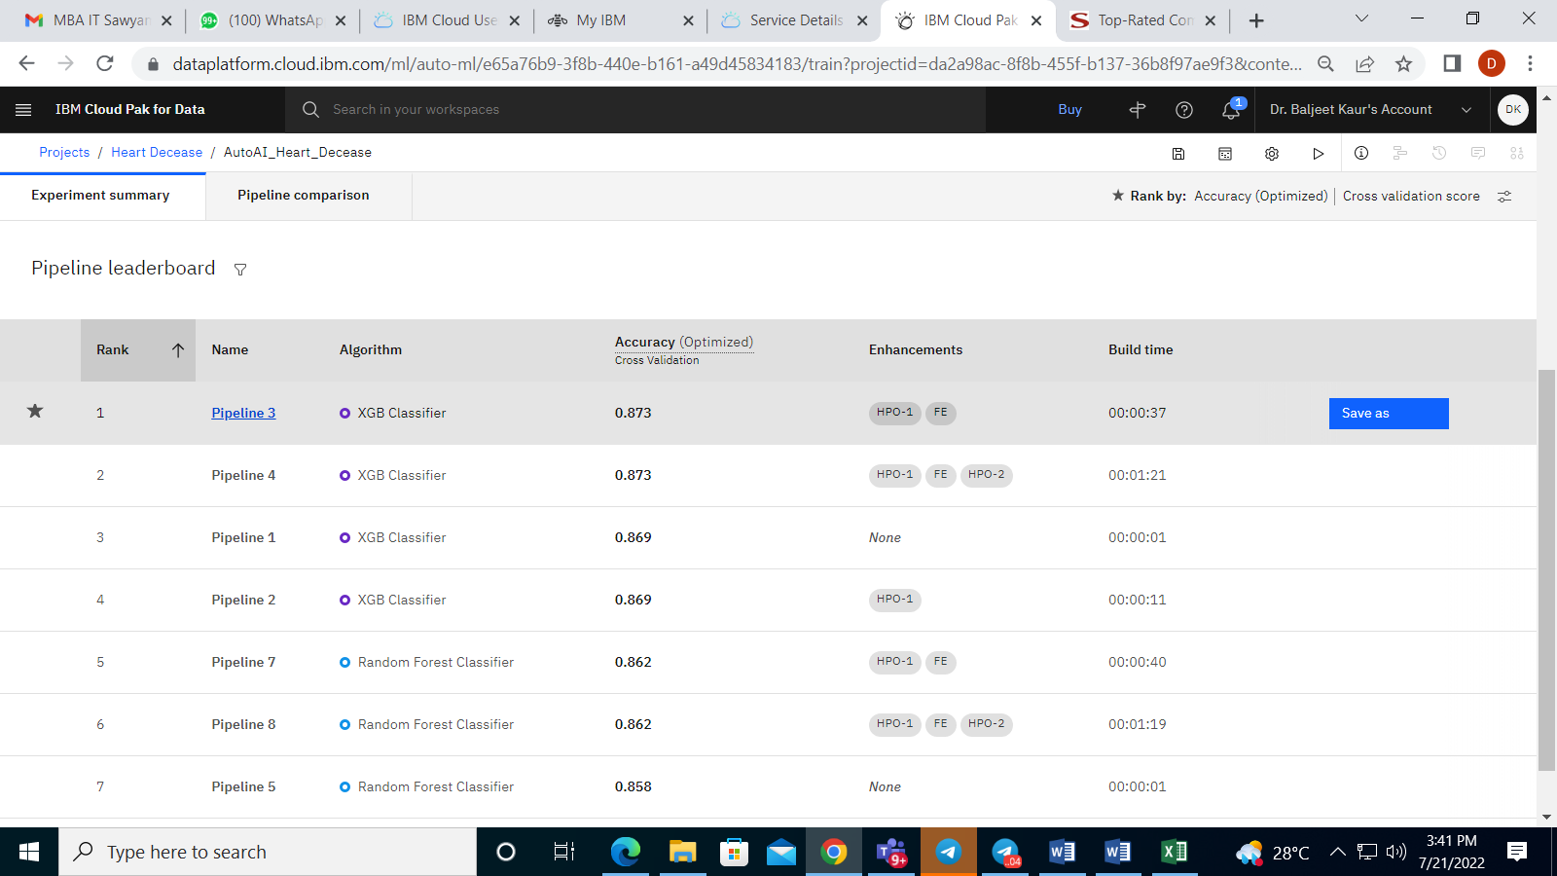

Saving the Model:

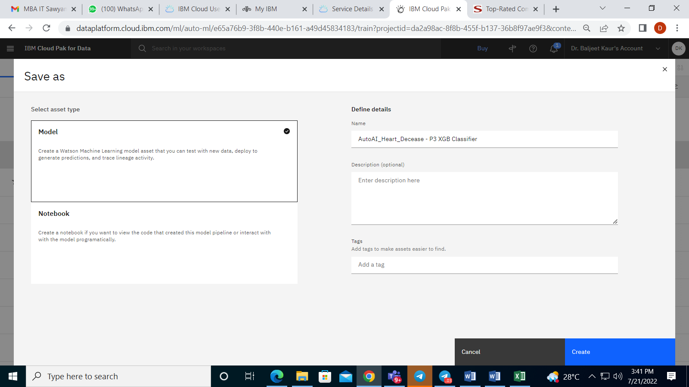

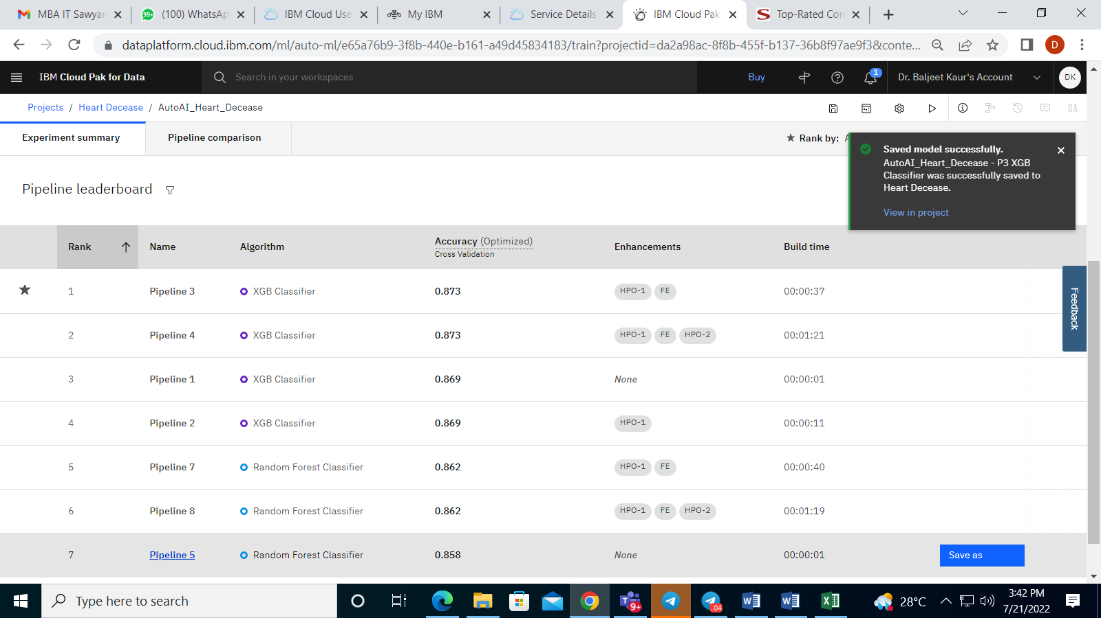

Promoting Model to deployment space:

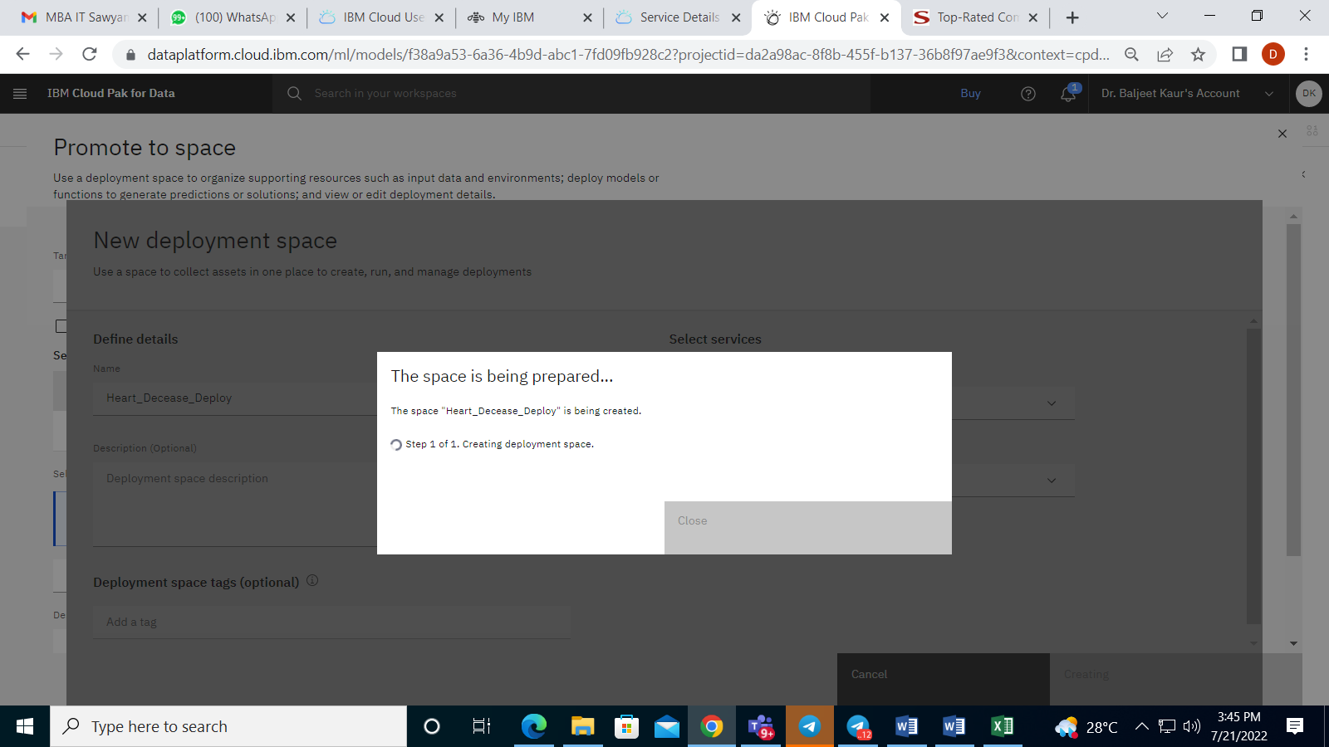

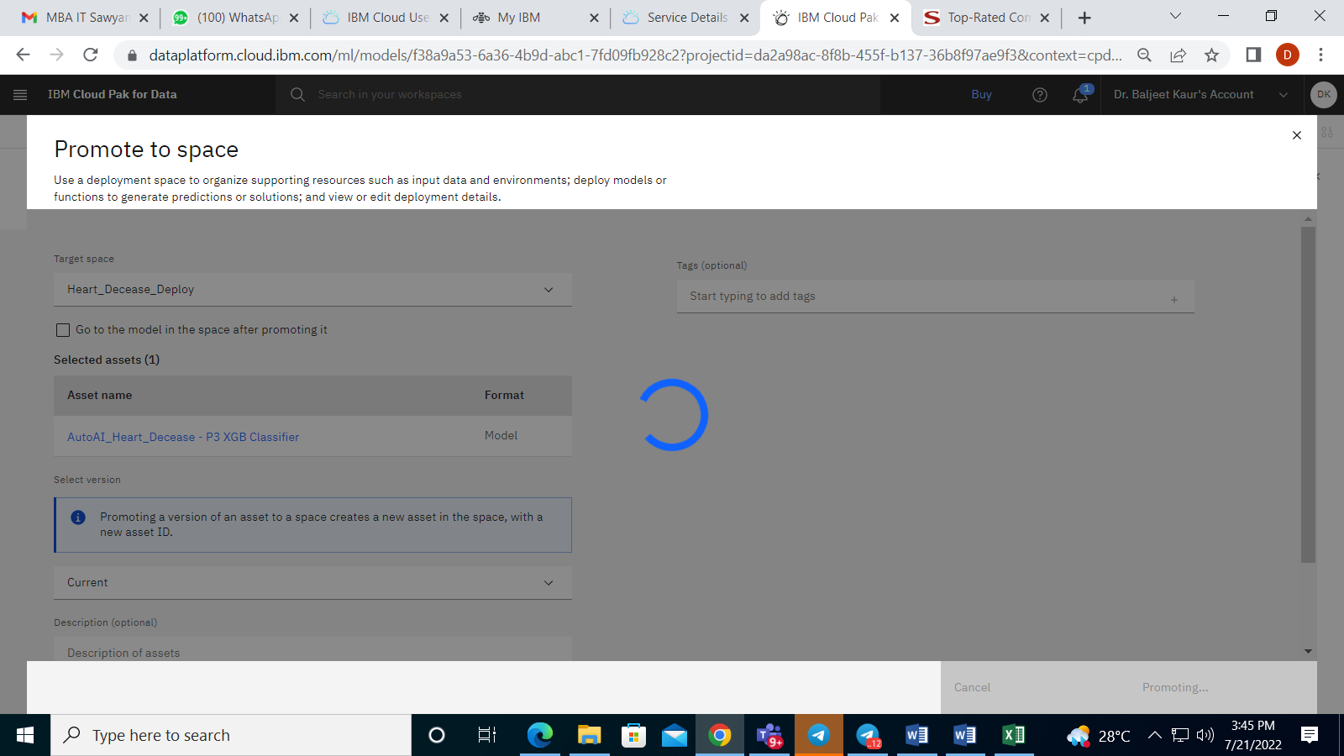

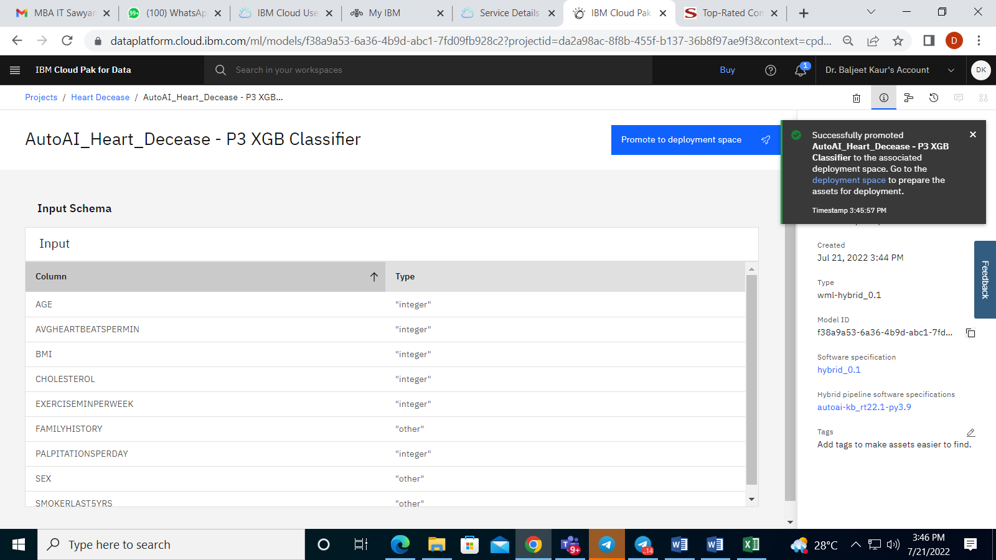

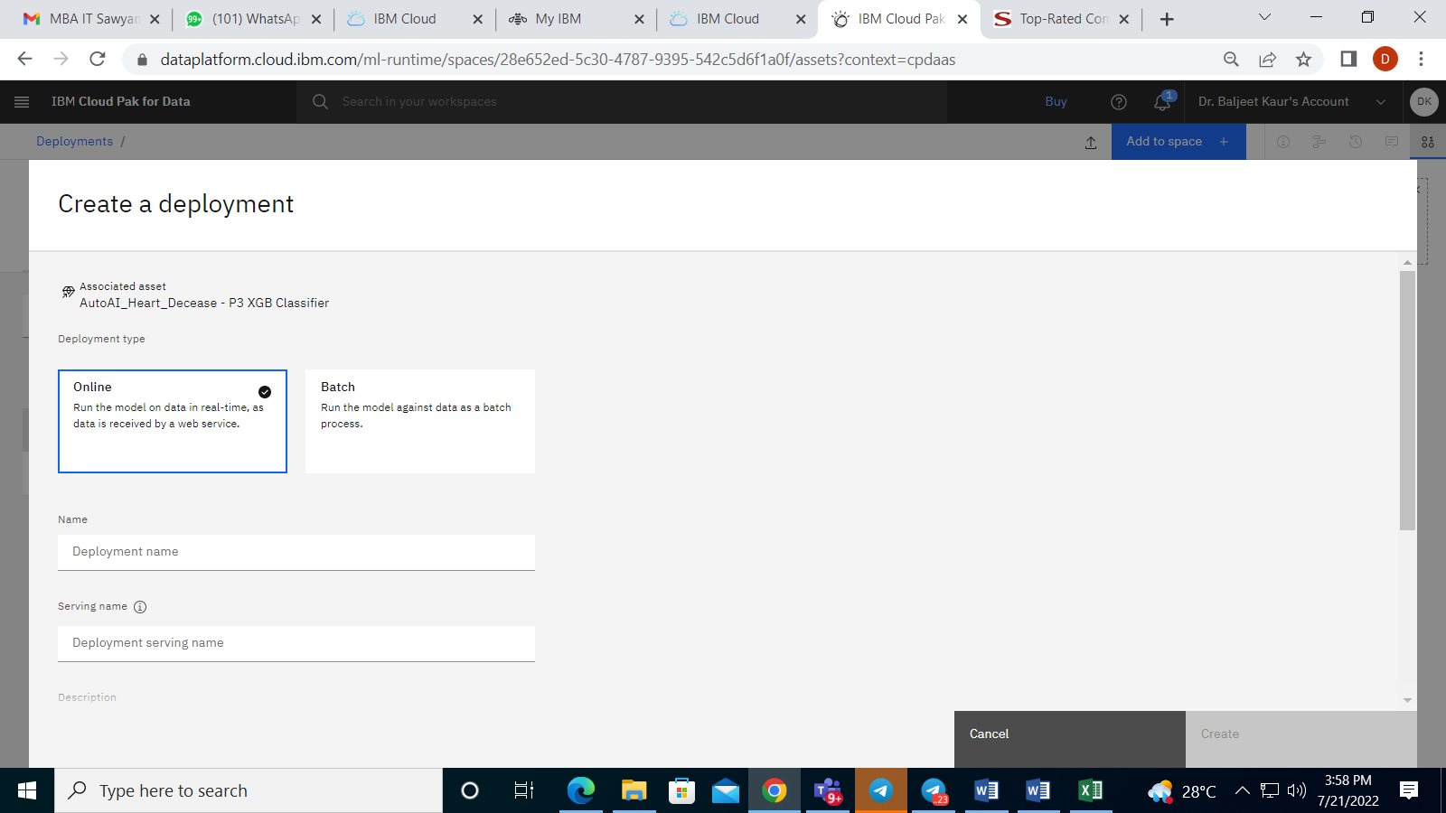

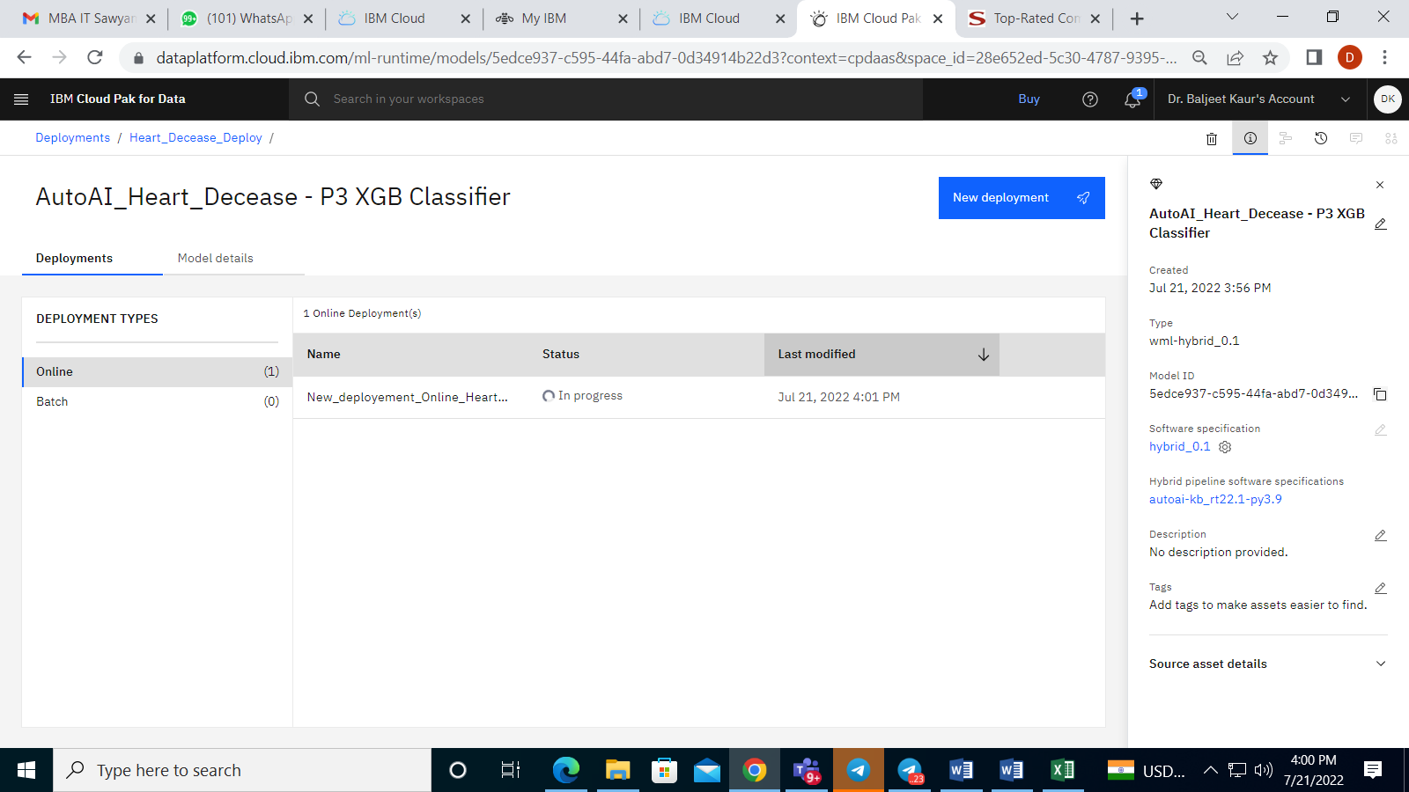

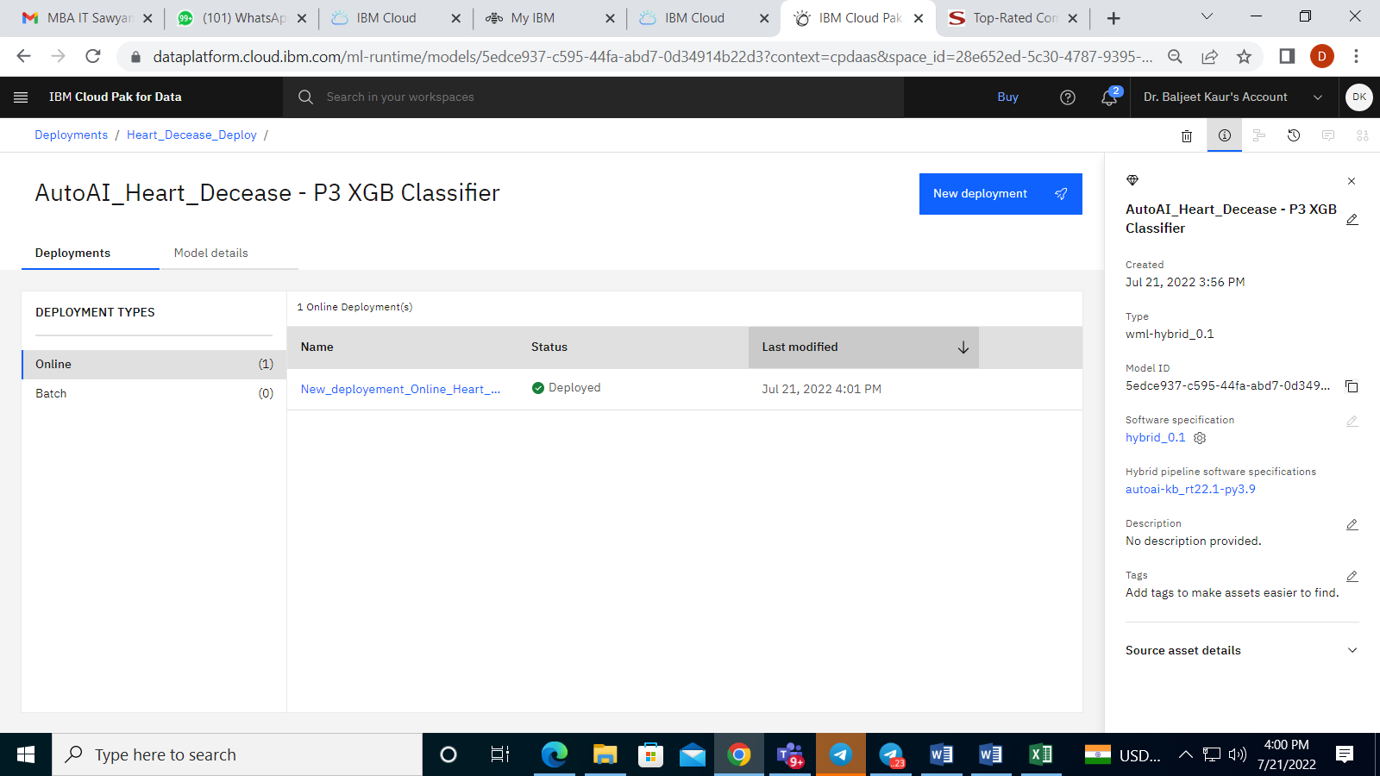

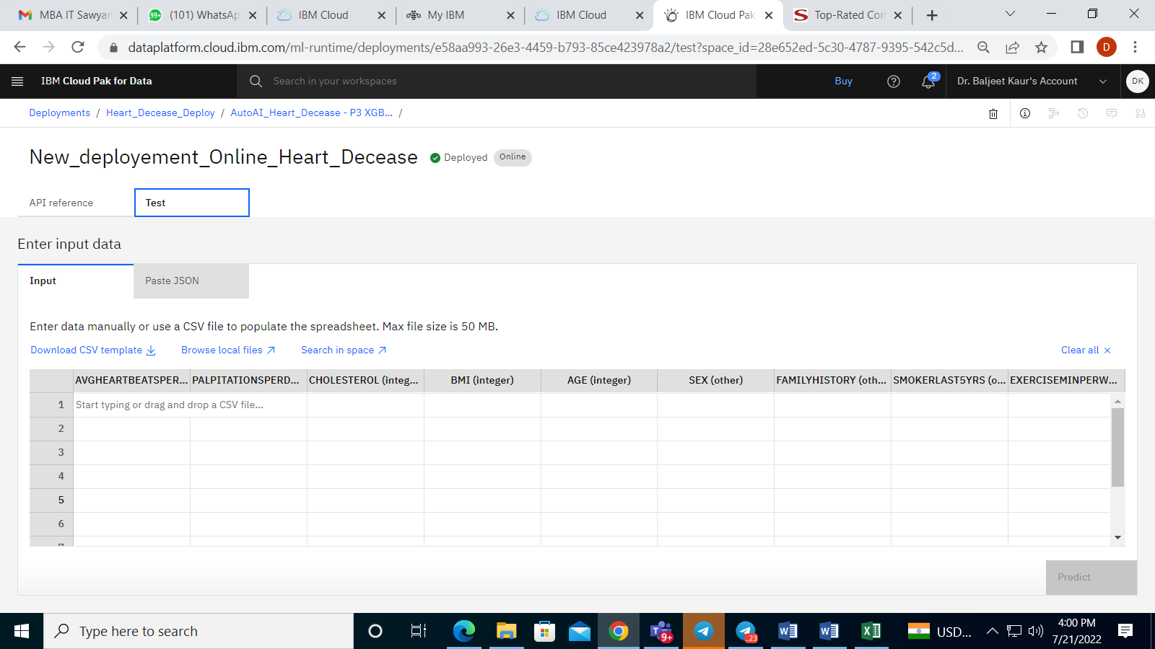

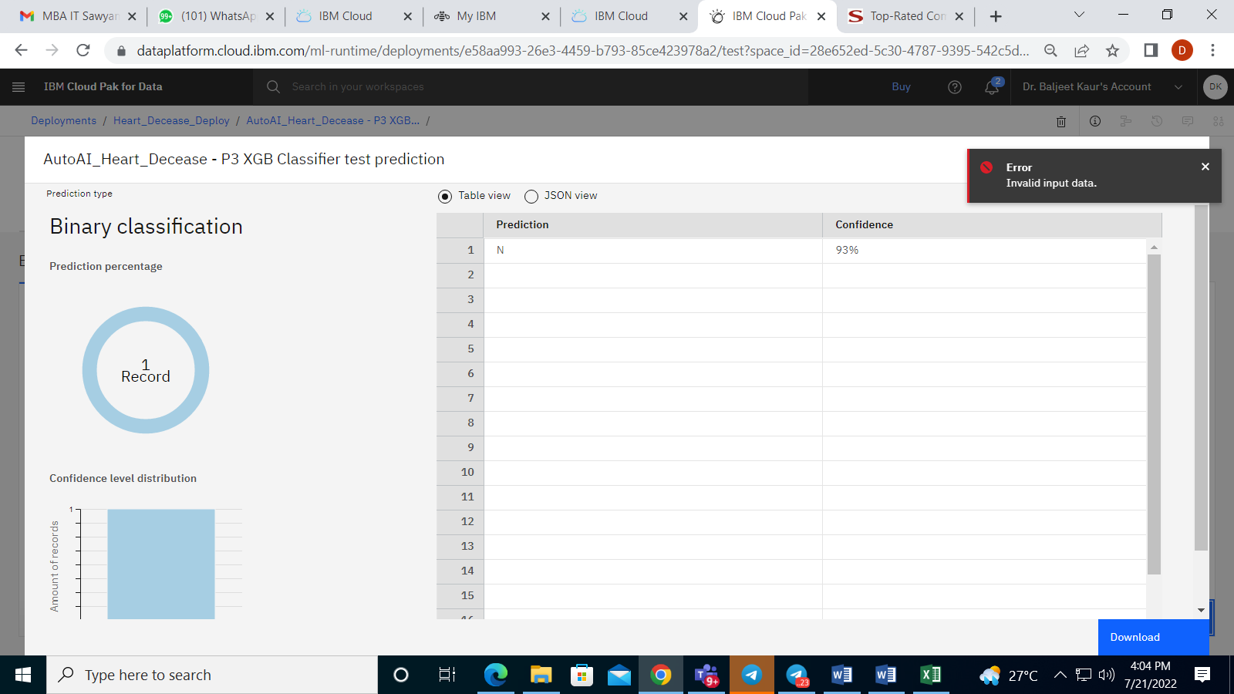

Creation of Node Red Service:

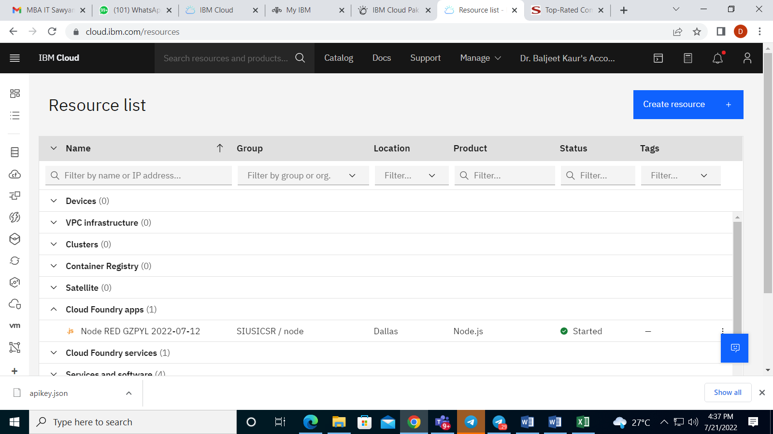

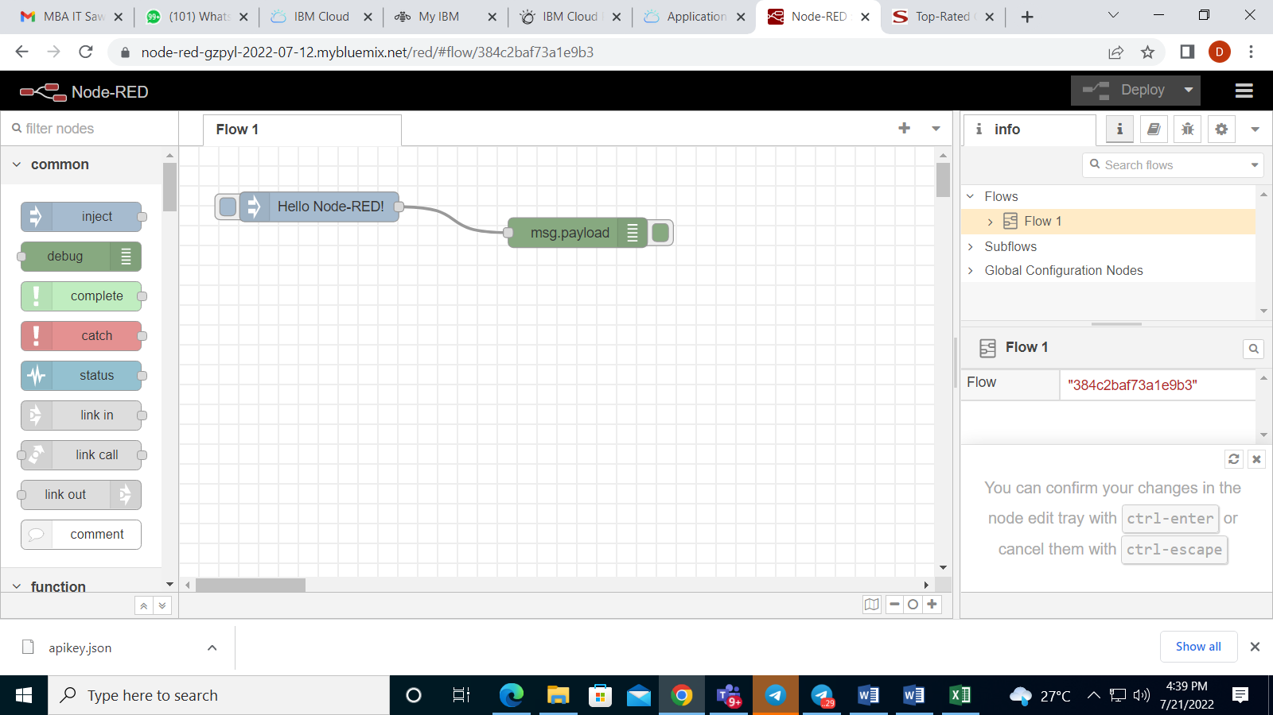

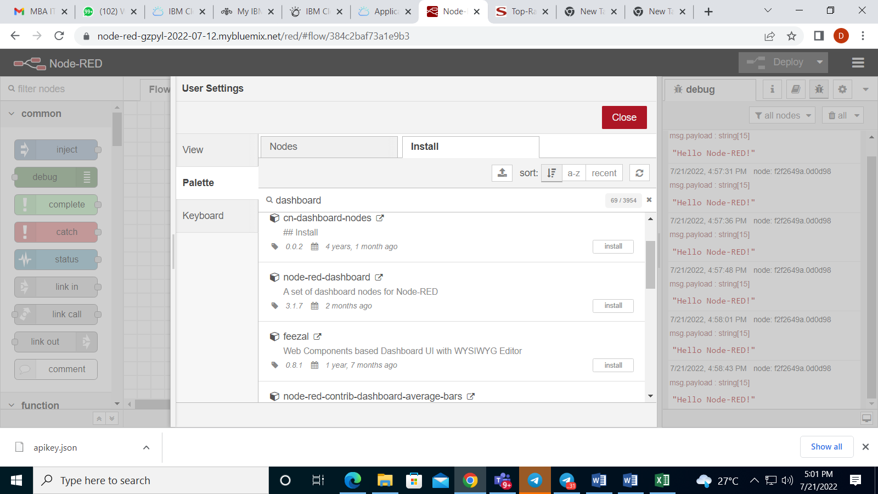

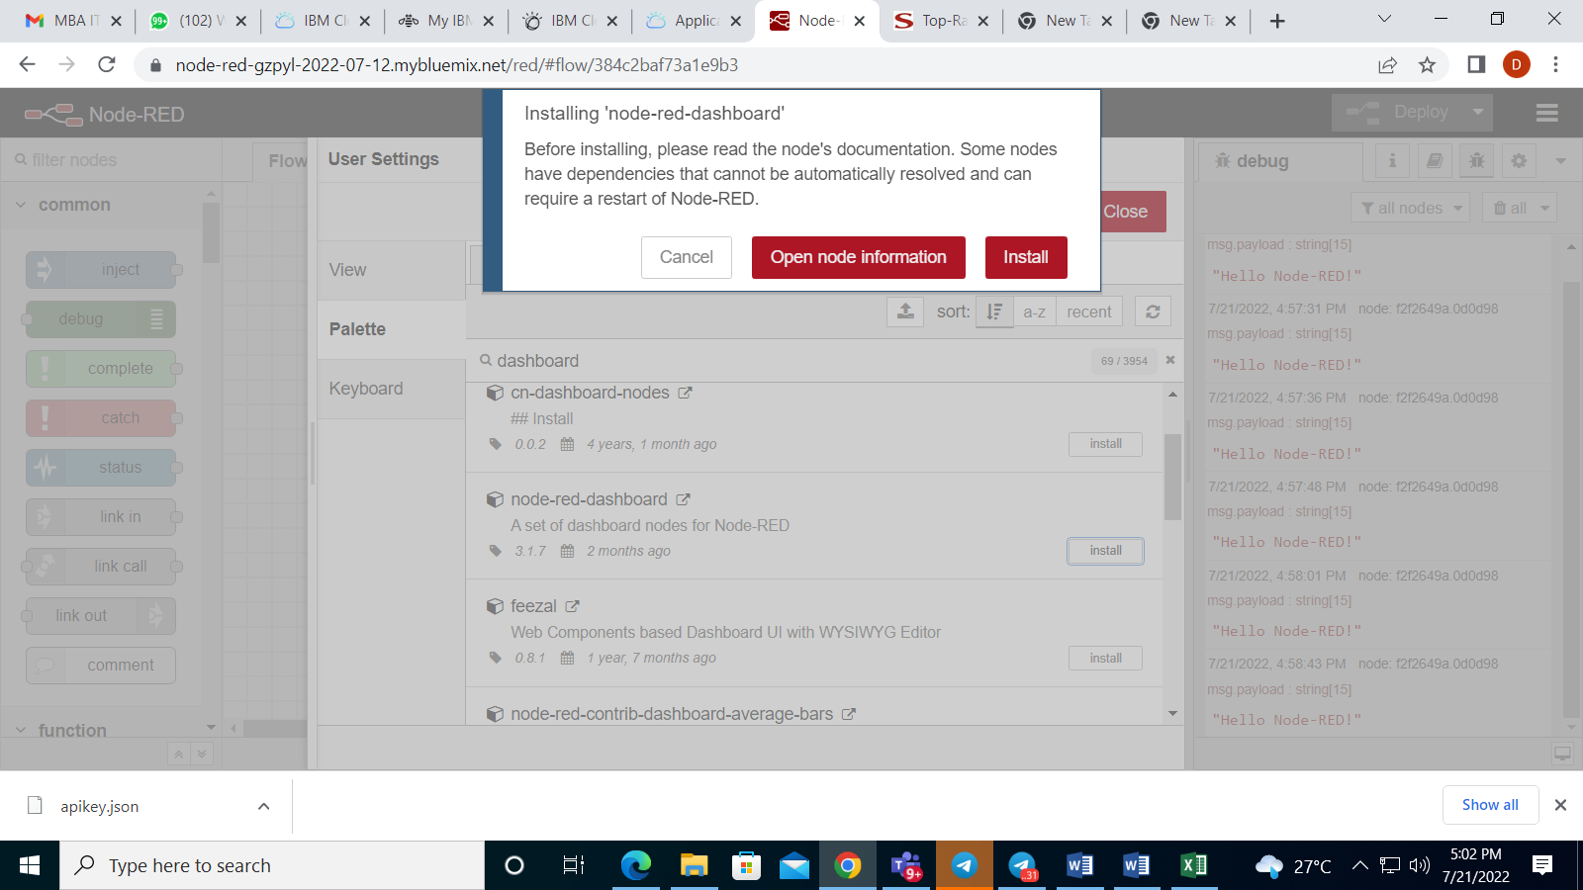

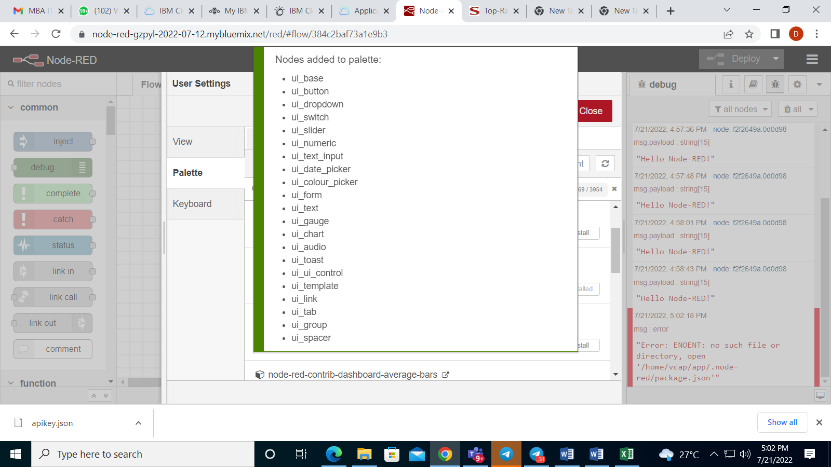

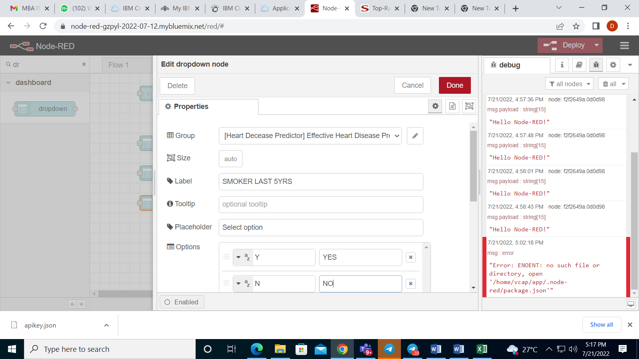

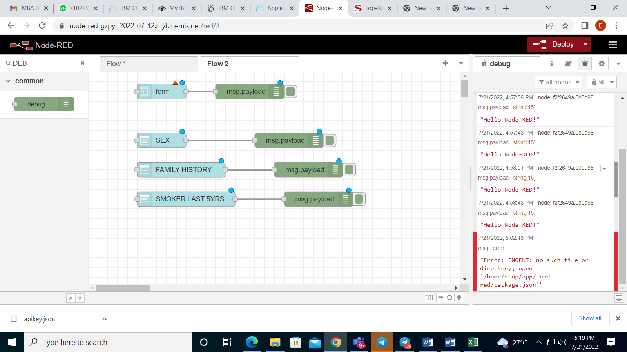

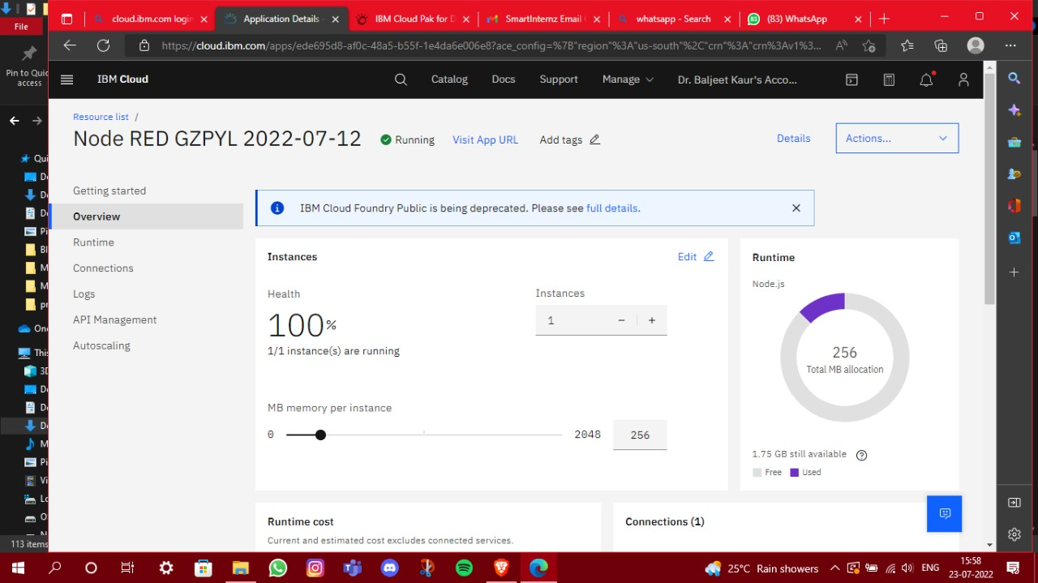

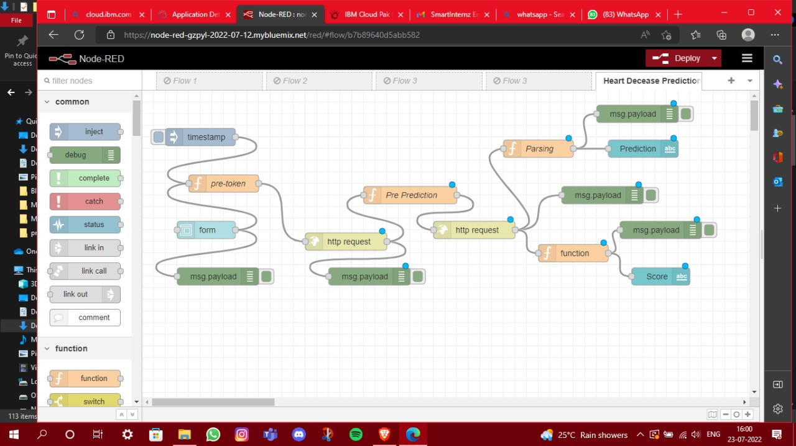

Launching the service Dashboard:

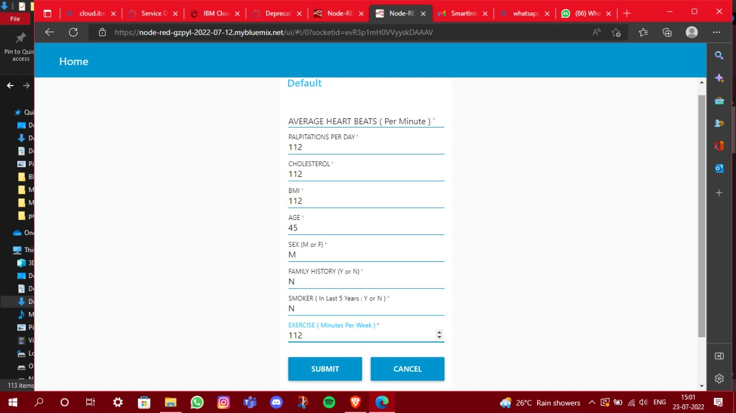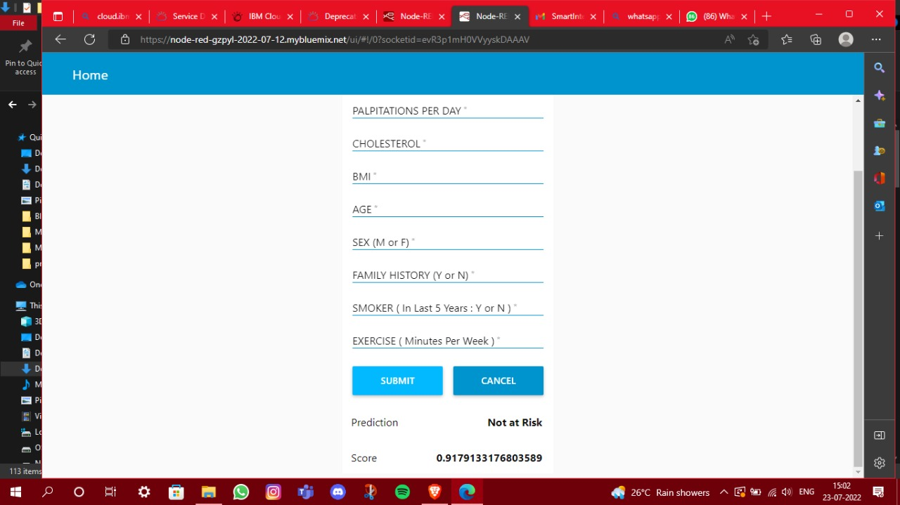

1. **FLOWCHART**

Diagram showing the control flow of the solution

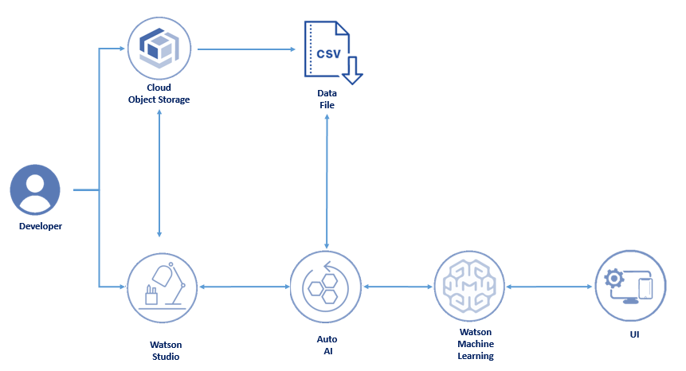

1. **RESULT**

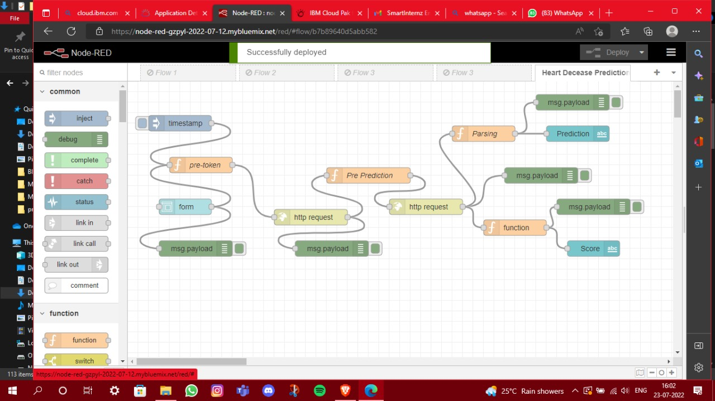

Launching the service Dashboard:



1. **ADVANTAGES & DISADVANTAGES**

      Advantages:

* 1. IBM Cloud provide end to end solution from taking data as input and providing prediction as output
  2. Organizations can concentrate of solution part of the problem that developing the model.

   Disadvantages;

1. Don't see any disadvantages as such.
2. A lot of customization is possible for setting up the experiment, so dont find any disadvantages.

1. **APPLICATIONS**

This is a wonderful solution for businesses which are looking for end to end solutions. Following are few examples:

* 1. Healthcare is a big market. Right from the timely diagnosis of the decease to smart health care solutions can use these services.
  2. Market Segmentation
  3. smart banking services
  4. Recommender systems

1. **CONCLUSION**

Heart failure is a common event caused by CVDs and this dataset contains 9 features that were used to predict mortality by heart failure. The Model was created using Auto AI Service. XGBoost provides was identifies as the best algorithm to identify heart failure and the algorithm was used to create the model. Auto AI used different hyper parameters to improve the performance of XGBoost. In this project, we created a model using Auto AI and build a web application which was launched with the help of Dashboard for the prediction of heart failure.

1. **FUTURE SCOPE**

One of the significant difficulties that India as a nation faces is that we have limited infrastructure for medical healthcare which result in delay in healthcare service and identifying a critical decease at early stage. If the simple dashboards are available for people to understand the critical stage of a decease or to diagnose a decease will be really good social service.

The Similar application can be scaled to multiple case studies in Finantial/ Marketing/ e-learning domains.

1. **BIBILOGRAPHY**

IBM Smartinternz Workshop attended from 6th July to 12th July 2022. Course material and tutorial was referred in solving assignment.

Day 1 Link- <https://www.youtube.com/watch?v=Zj-DFJpyT_A>

Day 2 Link- <https://youtu.be/4CMldzb701M>

Day 3 Link- <https://youtu.be/PSi_1DUr5og>

Day 4 Link- <https://youtu.be/Huc9wGetngA>

Day 5 Link- <https://youtu.be/R22RqlGvtzE>

Day 6 Link- <https://youtu.be/59QeXVdK8rY>